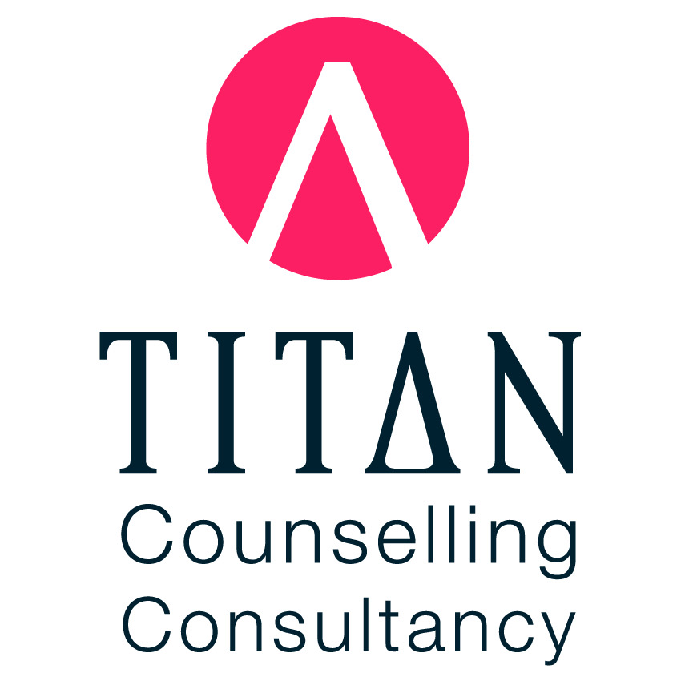

Privacy Policy

1. Purpose and Commitment
At Titan Counselling Consultancy, we are committed to protecting your privacy and ensuring your personal and sensitive information is handled in accordance with the Privacy Act 1988 (Cth), the Australian Privacy Principles (APPs), and professional codes of conduct (e.g., PACFA or ACA guidelines).

2. What Information We Collect
We collect personal and sensitive information including your name, contact details, medical and mental health history, presenting concerns, session notes, information from other professionals (with consent), billing details, and data generated through digital tools (including AI-based tools, if used).

3. How We Collect Information
Information is collected directly from you, through referrals (with consent), or via secure digital tools.

4. Use of AI Tools (if applicable)
If AI-assisted tools are used, their use is transparent, explainable, opt-in only, and never replaces human clinical judgement. Clients will always be informed and may opt out.

5. Purpose of Collection
Your personal information is used to provide psychological support, maintain records, communicate with you, collaborate with providers (with consent), and comply with legal and regulatory obligations.

6. Data Storage and Security
Your information is securely stored on encrypted systems and in locked physical locations. Only authorized personnel have access.

7. Disclosure of Information
We will only disclose your personal information with consent, where there is risk of harm, or as legally required (e.g., subpoena).

8. Access and Correction
You can request access to your records or corrections to any inaccuracies by contacting us in writing.

9. Third Parties and AI Providers
We ensure any third-party services comply with Australian privacy laws and clients are informed of their use.

10. Complaints
Privacy complaints can be directed to us in writing. If unresolved, they may be escalated to the OAIC or your practitioner’s regulatory body.

11. Policy Updates
This policy may be updated periodically. A current version will always be available on request or via our website (if applicable).

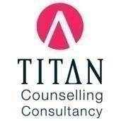 | Bradley McKay  General Counsellor  No: 0423312215  Email: titancounsellingconsultancy@gmail.com

